Thyroid orbitopathy:
Distance of the anterior surface of orbit from intezygomatic line is [] (normal is < 23 mm).
[Retroorbital muscles show increased T2 signal] and appear bulky mainly in the region of belly (relative sparing of the distal tendinous region).
The thickness of Inferior rectus muscle is =
The thickness of the medial rectus muscle is= **most important for prognosis
The thickness of the superior rectus muscle is =
[Retroorbital fat appears bulky ]
[Superior ophthalmic vein is patent] [and is not compressed] [but compressed]
Lacrimal gland is [normal]
Barret’s index is []. Optic nerve shows normal signal and appearance.
***Barrett's index is used to assess for dysthyroid optic neuropathy, a severe complication of thyroid-associated orbitopathy that can lead to permanent blindness ¹.

Measurement

Helps predicting dysthroid optic neurpathy

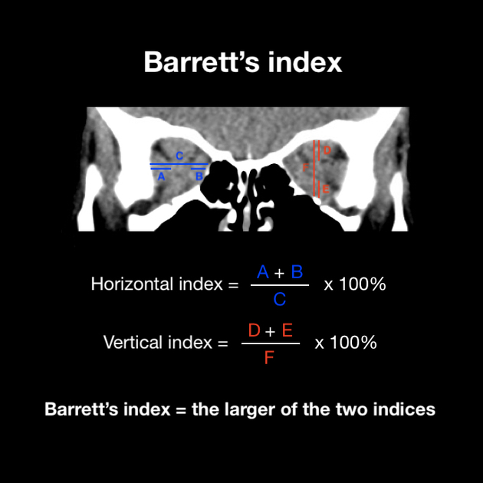
Measurement is calculated on coronal CT or MRI imaging of the orbits at a point halfway between the posterior globe and the orbital apex. Two measurements are taken for each eye:
- horizontal index
  - (width of medial rectus + width of lateral rectus) / orbital width through optic nerve x 100%
- vertical index
  - (height of superior rectus + height of inferior rectus) / orbital height through optic nerve x 100%
The larger of these two indices represents the more significant impingement and is the value taken as Barrett's index ².

Interpretation
A Barrett's index of ≥60% is highly sensitive and specific for dysthyroid optic neuropathy ³. A Barrett's index of <50% almost always excludes dysthyroid optic neuropathy ¹.

History and etymology
This method was first described by American radiologist Lynn Barrett in 1988 ².

[Normal] appearance of bony wall of orbit.

